LangGraph: Agent Orchestration and Workflows
Before understanding LangGraph, let's take a simple example.
Imagine I tell an AI agent:
“Find me a hotel in Bangalore under ₹3,000, check its availability, and book it for me.”
This sounds like one request, but the AI actually has to perform several tasks:
Search hotel → Check availability → Check price → Make a decision → Book hotel → Confirm booking
So, we need something that can manage and control these steps.
That is where LangGraph comes in.

1. Why LangGraph? — Agent Orchestration and Workflows
LangGraph is used to build and manage complex AI agent workflows.
I like to think of LangGraph as a traffic controller for AI agents.
A traffic controller decides which vehicle should go where and when.
Similarly, LangGraph decides:
- Which task should happen first?
- Which task should happen next?
- What should happen if something fails?
- Should the agent try again?
- Which path should the agent take?
For example:
User Request
↓
Search Hotel
↓
Check Availability
↓
Check Price
↓
Book Hotel
↓
Confirm Booking
Therefore, LangGraph helps orchestrate the complete workflow of an AI agent.

2. State Graphs and Node-Based Architecture
Now let's understand what a graph means in LangGraph.
A LangGraph workflow consists mainly of nodes and edges.
Nodes
A node represents a task or action.
For example:
Search Hotel
Check Availability
Calculate Price
Book Hotel
Each of these can be a node.
Edges
An edge connects one node to another.
For example:
Search Hotel
↓
Check Availability
↓
Calculate Price
↓
Book Hotel
So the easiest way to remember is:
“Nodes perform the tasks, and edges decide the flow between those tasks.”
This collection of nodes and edges forms the state graph.

3. Creating Nodes and Edges
Let's take the same hotel example.
We can create different nodes:
Node 1 → Search Hotel
Node 2 → Check Availability
Node 3 → Calculate Price
Node 4 → Book Hotel
Then we connect them using edges:
Search Hotel
↓
Check Availability
↓
Calculate Price
↓
Book Hotel
The workflow now knows what tasks need to be performed and in what order.
But real-world applications are not always this simple.
Sometimes something can go wrong.
For example:
Hotel is not available.
Instead of continuing to the booking step, the agent can go back and search for another hotel.
┌──→ Search Another Hotel
│
Search → Check Availability
│
└──→ Available → Book
This makes the workflow more flexible and intelligent.

4. State Management and Updates
Now let's understand state.
Imagine the user says:
“Find a hotel in Bangalore under ₹3,000.”
The agent needs to remember:
Location = Bangalore
Budget = ₹3,000
This information is called the state.
As the agent performs different tasks, the state can be updated.
For example:
Initial State
Location = Bangalore
Budget = ₹3,000

↓

Hotel Found
Price = ₹2,500

↓

Availability Checked
Available = Yes

↓

Booking
Status = Confirmed
So:
“State contains the information that the agent needs to remember and update throughout the workflow.”
This is especially useful when an agent performs multiple steps.

5. Conditional Routing
Now we come to one of the most interesting concepts: conditional routing.
Conditional routing means that the agent can choose what to do next depending on the result of a task.
For example:
Check Availability
↓
Is hotel available?
↙ ↘
YES NO
↓ ↓
Book Hotel Search Again
If the hotel is available:
YES → Book the hotel
If the hotel is not available:
NO → Search for another hotel
So, unlike a simple fixed workflow, LangGraph allows the agent to take different paths based on conditions.

Real-World Example
Let's put everything together.
Imagine an AI hotel booking agent:
User Request
↓
Search Hotel
↓
Check Availability
↙ ↘
YES NO
↓ ↓
Check Price Search Again
↓
Book Hotel
↓
Confirm Booking
Here:
- Nodes → Search, Check, Book
- Edges → Connect the tasks
- State → Stores location, budget, availability, etc.
- Conditional routing → Decides whether to book or search again
- LangGraph → Controls the complete workflow

Conclusion
You can finish your presentation with this:
“To conclude, LangGraph helps us build AI agents that can handle complex, multi-step workflows. I learned that nodes represent tasks, edges control the flow, state stores and updates information, and conditional routing allows the agent to make decisions and follow different paths.”
And finally:
“In simple words, LangGraph is like a traffic controller for AI agents—it manages the workflow and makes sure the agent takes the right step at the right time.”

Main.py
from typing import TypedDict
from langgraph.graph import StateGraph, START, END

# Define the state
class State(TypedDict):
name: str
message: str

# Node 1
def create_greeting(state: State):
return {
"message": f"Hello {state['name']}!"
}

# Node 2
def add_welcome(state: State):
return {
"message": state["message"] + " Welcome to LangGraph!"
}

# Create the graph
graph = StateGraph(State)

# Add nodes
graph.add_node("greeting", create_greeting)
graph.add_node("welcome", add_welcome)

# Add edges
graph.add_edge(START, "greeting")
graph.add_edge("greeting", "welcome")
graph.add_edge("welcome", END)

# Compile the graph
app = graph.compile()

# Run the workflow
result = app.invoke({
"name": "Ritha",
"message": ""
})

print(result["message"])

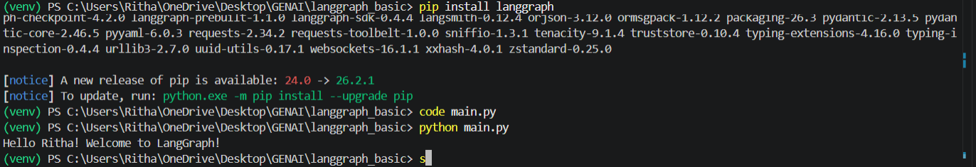

Conditional.py
from typing import TypedDict
from langgraph.graph import StateGraph, START, END

# Define State
class State(TypedDict):
age: int
result: str

# Node 1: Check age
def check_age(state: State):
return {}

# Conditional function
def decide(state: State):
if state["age"] >= 18:
return "eligible"
else:
return "not_eligible"

# Node 2: Eligible
def eligible(state: State):
return {"result": "You are eligible."}

# Node 3: Not Eligible
def not_eligible(state: State):
return {"result": "You are not eligible."}

# Create graph
graph = StateGraph(State)

# Add nodes
graph.add_node("check_age", check_age)
graph.add_node("eligible", eligible)
graph.add_node("not_eligible", not_eligible)

# Add normal edge
graph.add_edge(START, "check_age")

# Add conditional edges
graph.add_conditional_edges(
"check_age",
decide,
{
"eligible": "eligible",
"not_eligible": "not_eligible"
}
)

# Connect to END
graph.add_edge("eligible", END)
graph.add_edge("not_eligible", END)

# Compile
app = graph.compile()

# Run workflow
result = app.invoke({
"age": 15,
"result": ""
})

print(result["result"])

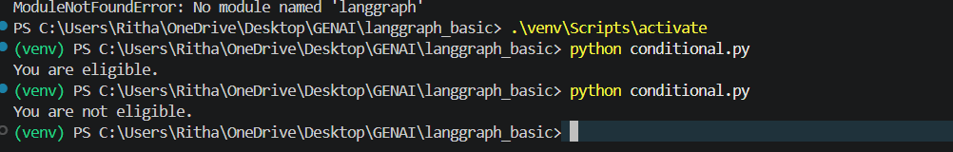

state_update.py
from typing import TypedDict
from langgraph.graph import StateGraph, START, END

# Define the state
class State(TypedDict):
name: str
message: str

# Node 1: Create greeting
def create_greeting(state: State):
return {
"message": f"Hello {state['name']}!"
}

# Node 2: Update the message
def add_welcome(state: State):
return {
"message": state["message"] + " Welcome to our AI application!"
}

# Create the graph
graph = StateGraph(State)

# Add nodes
graph.add_node("greeting", create_greeting)
graph.add_node("welcome", add_welcome)

# Connect nodes
graph.add_edge(START, "greeting")
graph.add_edge("greeting", "welcome")
graph.add_edge("welcome", END)

# Compile
app = graph.compile()

# Run
result = app.invoke({
"name": "Ritha",
"message": ""
})

print(result["message"])

